MIZAN TEPI UNIVERSITY

COLLEGE OF ENGINEERING AND TECHNOLOGY

DEPARTMENT OF MECHANICAL ENGINEERING

MENG – 3161 MECHANICAL VIBRATION LAB EXPERIMENTS



SUBMITTED BY

NAME ID/NO

TEPPI – 2019

**TORSIONAL APPARATUS**

1. INTRODUCTION

The theory of vibrations is a particularly complex area for trainees who make exacting demands of their basic knowledge of mathematics and physics. Nevertheless, a fundamental understanding of this subject is an indispensable part of many technical professions. The conducting of actual experiments provides an excellent means of helping trainees become familiar with this branch of physics. The Torsional Vibration Apparatus TM 140 designed especially for treating this demanding topic enables experiments to be performed covering a wide range of subjects relating to torsional vibration. These include:

(i)Torsional rigidity

(ii) Mass moments of inertia

(iii) Free and forced torsional vibration

(iv) Damped torsional vibration

(v) Resonance effects

(vi) Oscillator with several masses

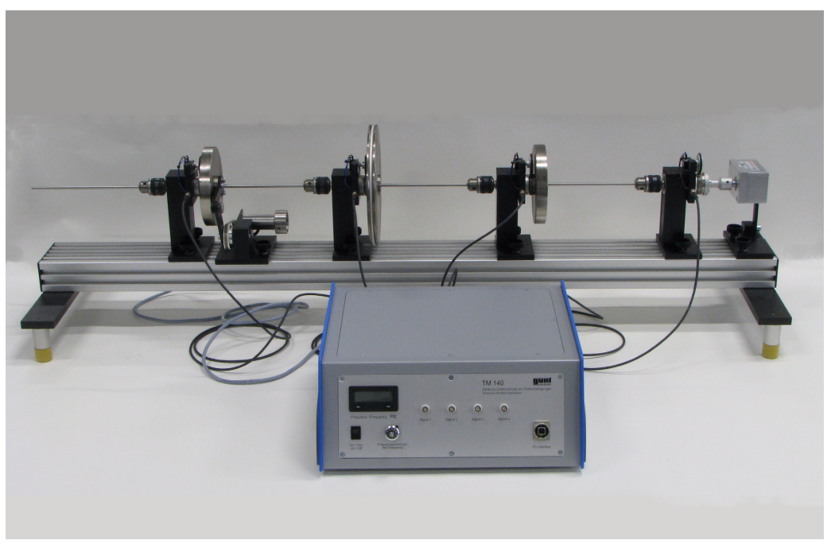

**TORSIONAL APPARATUS**

1. **DETERMINATION OF TORSION RIGIDITY:**

The rigidity of a torsional vibration system is an important system parameter. This experiment is designed to determine the torsional rigidity of the torsion bar and compare it to the theoretical result. The following applies to the torsion of a round bar:

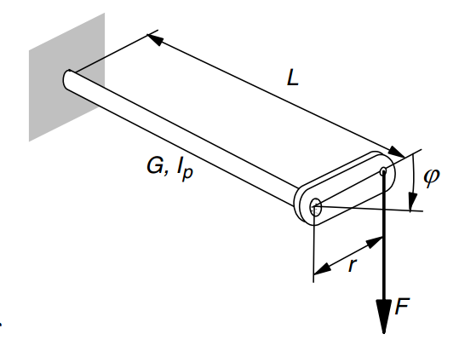

EXPERIMENTATION SET-UP

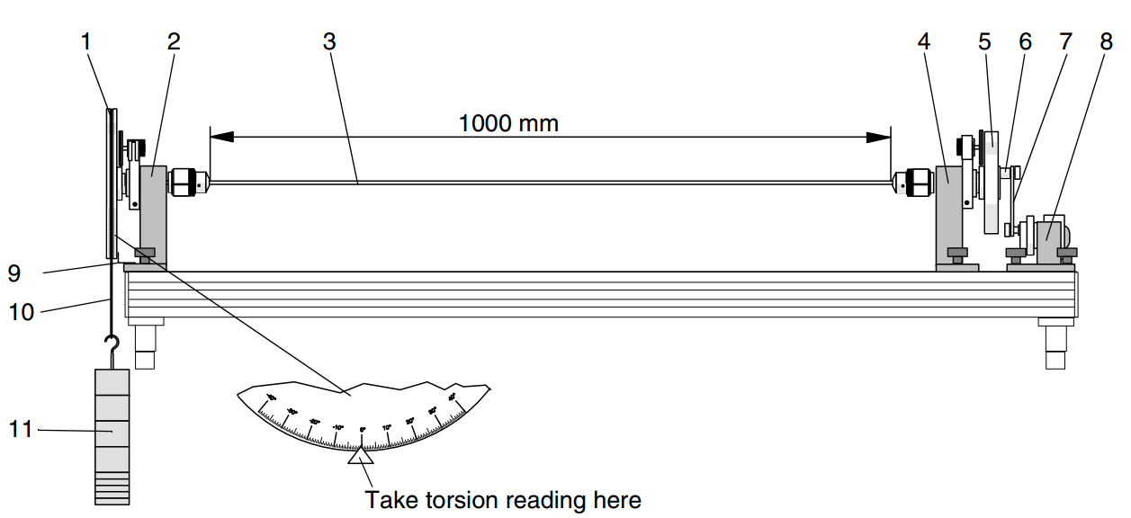

* Clamp on left bearing unit (2) (with pointer (9) at base plate) flush with end of frame. Chuck must face center of frame.
* Screw large disc (1) with 3 bolts to drive flange. Make sure angle scale on disc faces bearing unit.
* Position right bearing unit (4) on frame, align at 1000 mm between chucks and secure. Chuck must face center of frame.
* Slip long torsion bar (3) from one side through the two drivers and secure with right chuck.
* Attach small disc (5) and drive lever (6) to right drive flange with 3 bolts.
* Mount exciter unit (8) on right end of frame. Connect crank and drive lever with connecting rod (7). Clamp exciter unit in position. This blocks the right end of the bar. The exciter motor remains switched off.
* Position end of rope with ball in groove (12) and wrap rope (9) around large disc (1).
* Align large disc such that scale is set to zero. Tighten left chuck.
* Weight (11) can now be fitted.

performance of experiment and evaluation

* Check chucks. These must be tightened very firmly to prevent slipping under heavy load.
* Increase load in increments of 5 N up to a total of 25 N.
* Read off and note down deflection.
* Convert angle to rad:

|  |  |  |  |  |
| --- | --- | --- | --- | --- |
| Measured rigidity  With r = 110 mm, L = 1000 mm, and D = 6 mm | | | | |
| Force F  ‘N’ | Angle ϕ0  In 0 | Angle ϕ0  In rad | Rigidity Cϕ  In Nmm/rad | Remarks |
|  |  |  |  |  |
|  |  |  |  |  |
|  |  |  |  |  |
|  |  |  |  |  |
|  |  |  |  |  |
|  |  |  |  |  |

Comparison with theoretical results reveals a high level of coincidence:

Draw the graph force / torsion curve:

1. MASS MOMENT OF INERTIA

Basic principles

A further important parameter of a torsional vibration system is the torsional inertia or mass moment of inertia. This experiment is designed to determine the mass moment of inertia for the two discs and to compare this to the theoretical result. The mass moment of inertia is determined by performing an acceleration experiment. A drive torque, produced by a force due to weight at a lever arm, induces uniformly accelerated rotation of the disc. The following applies to the disc:

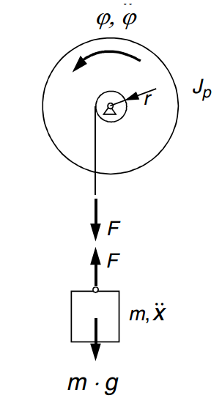

Experiment set-up

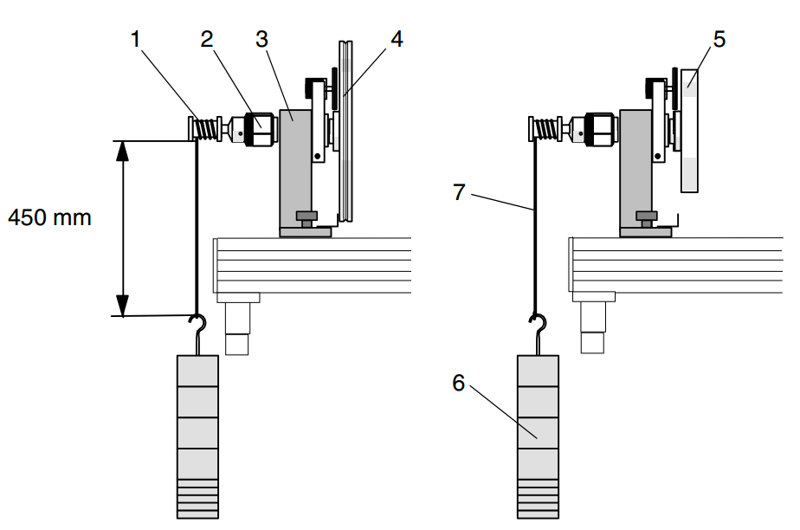

Uniformly accelerated rotation

* Secure left bearing unit (3) at the end of the frame. The chuck (2) must face away from the frame.
* Attach large disc (4) or small disc (5) to drive flange using 3 bolts.
* Clamp small rope reel (1) with rope (7) in chuck (2).
* Set up apparatus such that the weight (6) can freely travel through a distance of at least  
  450 mm.

**Performance of experiment and evaluation**

The first step is to determine the friction force.

* Fit weight holder without additional weights (1 N).
* Wrap rope around rope reel and check whether disc starts to turn off its own accord.
* If necessary add more 1N weights.
* The experiment revealed that a force of 1-2 N = 1.5 N, was needed to start the disc turning. This force has to be subsequently subtracted.
* The time is measured with a stopwatch.
* Attach 5 N weights.
* Wrap rope around rope reel and hold disc.
* Release disc and measure time for a distance of 450 mm.
* Repeat the experiment with the other disk.

|  |  |  |  |  |  |  |
| --- | --- | --- | --- | --- | --- | --- |
| Measured mass moment of inertia  R = 5 mm, s = 450 mm | | | | | | |
| Disc | Force F  In N | Friction  In N | Corresponding force F in N | Time t  In sec | MMI measured  In kgm2 | MMI calculated in kgm2 |
|  |  |  |  |  |  |  |
|  |  |  |  |  |  |  |

**VIBRATION APPARATUS**

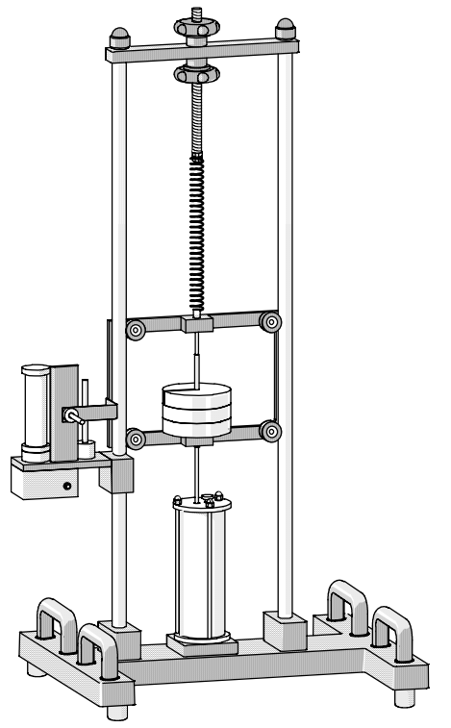

**Oscillation theory** is a particularly difficult area for trainees. It makes exacting demands of the trainee’s basic knowledge of mathematics and physics, but at the same time a fundamental understanding of oscillations is indispensable for working in technical professions. **Visual-aid experiments** represent an appropriate means of enabling trainees to better comprehend this branch of physics.

The **Vibration Apparatus TM 160** specially designed for this difficult field enables a variety of oscillation-related topics to be treated in experimental form.

The spectrum provided includes:

1. Determination of spring constant
2. Determination of natural frequency
3. Influence of mass
4. Un-damped oscillations
5. Damped oscillations
6. Determination of degree of damping

All experiments are appropriate to **demonstration** and **practical exercises**. A **mechanical recorder** is provided for plotting oscillatory phenomena. Each section of these instructions is preceded by a **short theory introduction,** where the most important terms, such as the equation of motion, solving methods, natural frequency, degree of damping etc. are explained before being illustrated by way of the following experiment. This provides the **association between theory**  
**and experiment** which is so necessary for exploring such a demanding field.

**Determination of spring constant**

The spring constant is a characteristic indicating the relationship between spring load and the deflection of the spring. With the helical springs normally used this relationship is linear, i.e.   
doubling the load doubles the deflection of the spring. The following equation gives the relationship between **spring load F** and spring deflection x

*F* = *c* ⋅ *x*

Where c is the **spring constant**. For the purpose of experimental determination, the spring is loaded by fitting weights m and the extension x measured.

C = (m2 – m1) / x2 – x1

As a check on linearity, the measured values can also be plotted on a **load-extension curve**.

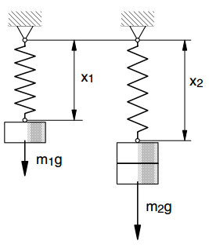 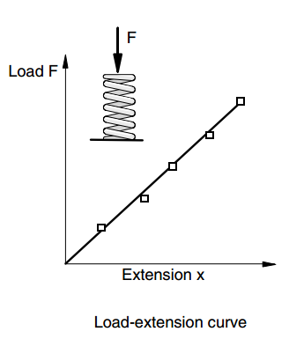

**Performance of experiment**

It is appropriate to plot the extension of the spring with the recorder.

* Fit paper and stylus
* Remove weights from carriage.
* Use adjuster to set carriage such that stylus is on 20 mm line on chart paper.
* Load spring by placing weights on carriage.
* Briefly start recorder after each weight is added.

**Evaluation of experiment**

The degrees of extension are read from the measurement record and entered in a table.

|  |  |  |  |  |
| --- | --- | --- | --- | --- |
| Determination of spring constants | | | | |
| S.no | Mass in kg | Load in N | Deflection in mm | Extension in mm |
| 1 |  |  |  |  |
| 2 |  |  |  |  |
| 3 |  |  |  |  |
| 4 |  |  |  |  |
| 5 |  |  |  |  |
| ` |  |  |  |  |

Referenced to maximum load, the spring constant is as follows (theoretical constant in brackets)

The experimental results coincide fairly well with the theoretical values. The measured values are plotted on a curve to check for linearity.

**Natural oscillations or free vibrations**

The term **natural oscillations** refers to the normal vibration of an uninfluenced oscillatory system. It is initially deflected out of its equilibrium position and then oscillates about this until it is brought to rest by any external or internal damping.

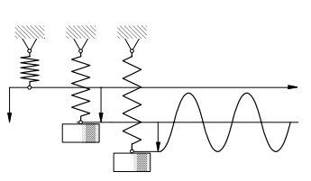 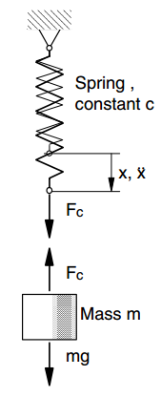

**Un-damped oscillations**

**(i).Equation of motion**

**Performance of experiment**

This experiment is designed to compare the theoretical natural frequency calculated for various  
masses to the values obtained by measurement.

* Mass of carriage m= 1.250 kg
* Additional mass mz = 2, 4, 6, 8, 10 kg
* Spring constant c =1.71 N/mm or 1710 N/m

|  |  |  |  |
| --- | --- | --- | --- |
| Influence of spring constant Natural frequencies calculated | | | |
| Experiment | Additional masses in ‘kg’ | Total mass in ‘kg’ | Natural frequency ‘f’ in Hz |
|  |  |  |  |
|  |  |  |  |
|  |  |  |  |
|  |  |  |  |
|  |  |  |  |
|  |  |  |  |

As the **experiments are performed without damping,** the damper is to be disconnected.

* + - Fit stylus
    - Attach chosen additional mass and secure with knurled nut.
    - Use adjuster to set height of carriage such that stylus is centered on paper.
    - Start recorder.
    - Deflect carriage downwards by hand and allow oscillating freely until it comes to rest.
    - Stop recorder.

Repeat experiment with other additional masses.

**Results of experiment**

The **free oscillation process** is illustrated by the following original measurement records.  
The free oscillations are damped by the friction of the stylus. The virtually linear amplitude decay over time is typical of friction damping. The distance for 10 oscillations was measured  
from the record and used to calculate the period at the **recorder speed of 20 mm/s**.

The measured frequencies are compared in the table to the theoretical results. There is a high degree of coincidence between the two.

|  |  |  |  |
| --- | --- | --- | --- |
| Frequencies of un-damped oscillations | | | |
| Experiment No | Experiment | | Theoretical frequency  In Hz |
| Period in’ s’ | Frequency in Hz |
|  |  |  |  |
|  |  |  |  |
|  |  |  |  |
|  |  |  |  |
|  |  |  |  |